NATIONAL RAGGING PREVENTION PROGRAMME
National Anti-Ragging Helpline
24x7 Toll Free
1800-180-5522
helpline@antiragging.in | www.antiragging.in
UGC Monitoring Agency
Centre for Youth (C4Y)
antiragging@c4yindia.org | www.c4yindia.org
Contact Details of the Nodal Officers of Anti-Ragging Committee and Squad
Anti-Ragging Committee (ARC) | Anti-Ragging Squad (ARS)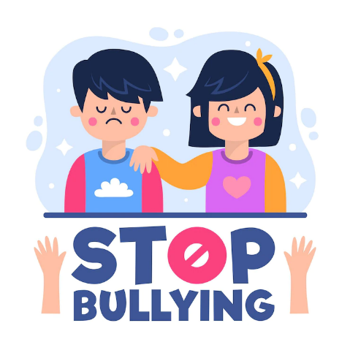
Undertaking Fill Compliance

Being ragged Get documents

RAGGING IS A CRIMINAL OFFENCE AND THE CULPRITS WILL ATTRACT
PUNITIVE ACTION AS MENTIONED IN THE UGC REGULATIONS
(www.antiragging.in/assets/pdf/annexure/Annexure-I.pdf)
www.ugc.ac.in

